Young Earth and Fictional Geologies

Jack Oliver

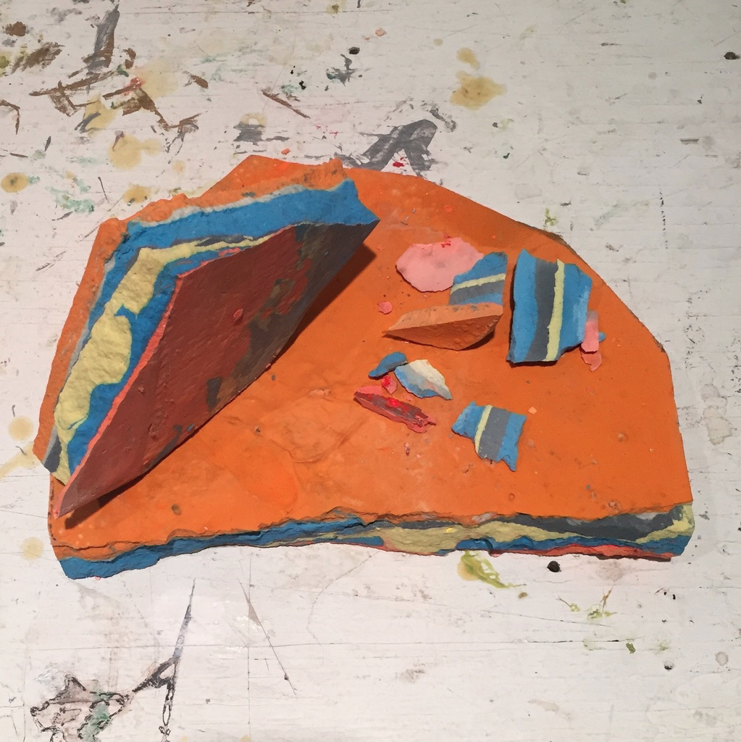

*Shards of the Young Earth, fresh and cracked from the mold.*

*Poured plaster colored with acrylic paint.*

Earlier this year I began researching the connections between the body, its mineral character, and the geological character of the Earth, hoping to illuminate a point of intersection between the three from which the situation of the human body in deep time was more apparent. My hypothesis going into the research process was that careful study of geologic change over time would be a useful way to de-anthropocentrize our perception of the physical world. Clearly it is hard for us to imagine time on this scale, but I was somewhat surprised to learn that there have been quite a few geologists in the last two centuries who have tried to reframe geology to reintroduce anthropocentric interpretations as to the formation of the mineral sphere. In particular I’m referring to creationist geologists, religious scientists who studied the Earth in order to reaffirm their beliefs that a human-like consciousness or will was responsible for Earth’s deliberate creation. Many of these individuals adamantly believed that the Earth had only existed for around 6000 years, a fundamentalist belief that is often called “Young Earth Creationism.” This was my introduction to the concept of geology as fiction.

Besides exploring geological fictions and the construction of geological narratives, I found that simulating geological processes was a natural tie-in to my ongoing methodology of “reverse-skeuomorphism,” reverse-engineering the intuitions and tendencies afforded by digital means of production. Physically simulating sedimentation with poured plaster was a funny analogue to “falling sand” flash games I spent hours playing as a kid, in which you could use your mouse to pour sands of different properties into a contained virtual environment. Similarly, I relate the process to other “sandbox style” simulation games, in which the player acts with a godlike omnipotence over the unfolding of the virtual world.

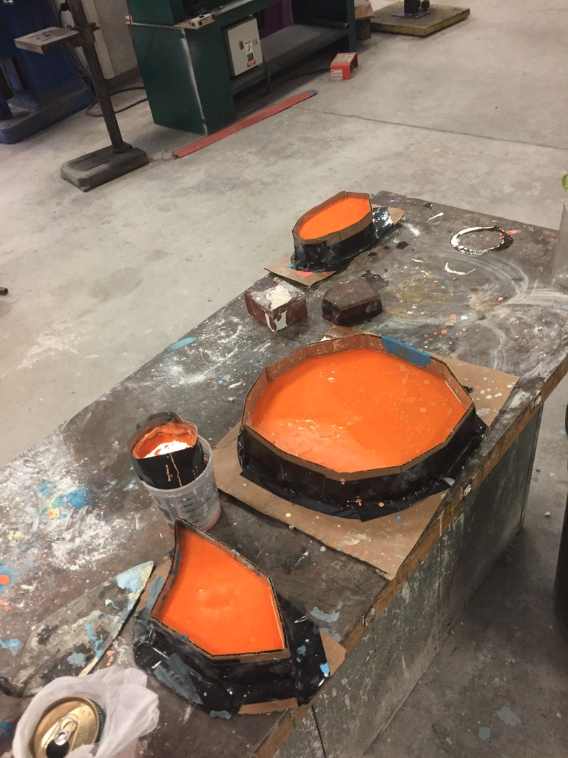

Sedimentary rock is a natural corrolary in the geologic sphere to the mineral systems of the body. Not only is much of sedimentary rock, like sandstone, composed of remnants of organic matter, but also the process of deposition in the Earth’s crust mirrors the bodily process of ossification, in which calcium-rich mineral material is deposited along the skeleton.

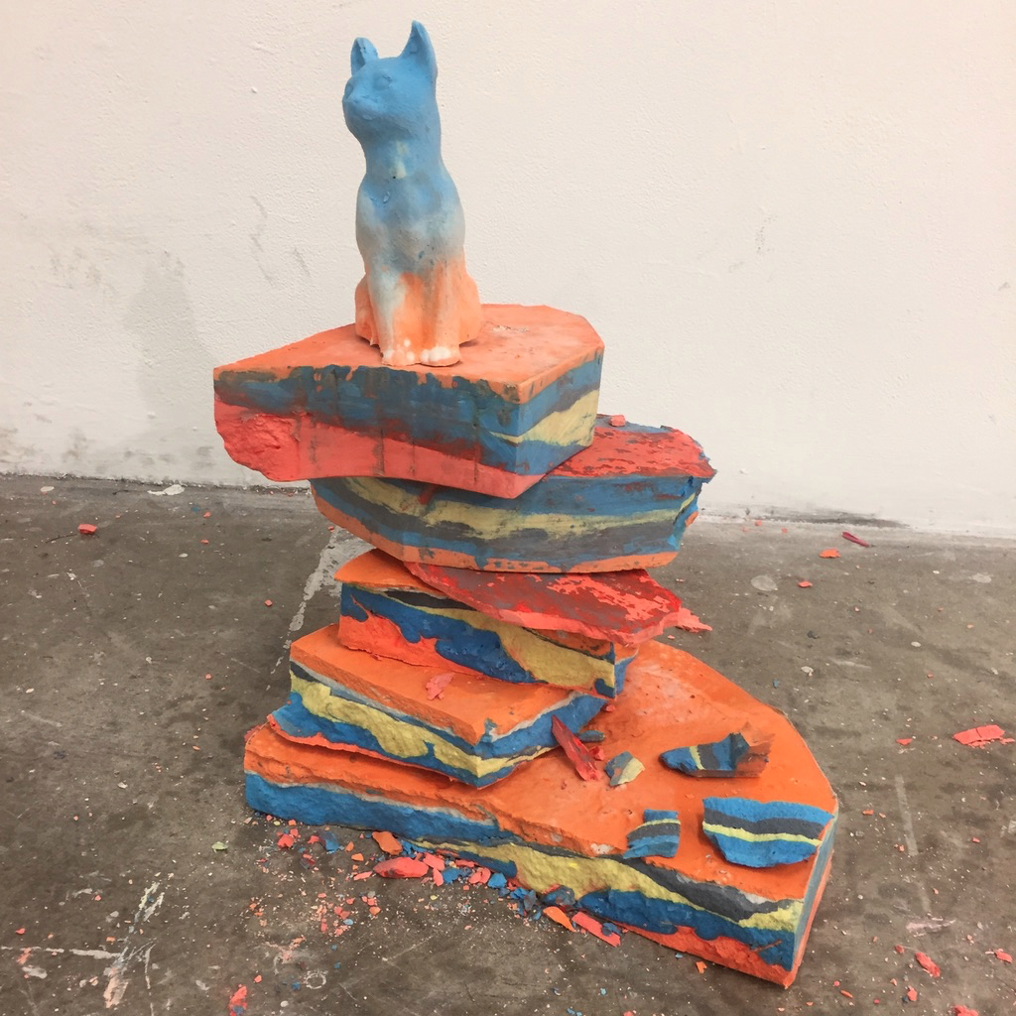

I chose to use bright colors to accentuate the contrast between strata, but over time they came to embody a certain emerging childlike character to the work. Fitting, I thought, for a project tied to the idea of the Young Earth. In my first critique the idea came up that my artificial sedimentary rocks could well become aids in educating young students in Earth science. From this point on I kept the potential pedagogical utility of the work in mind.

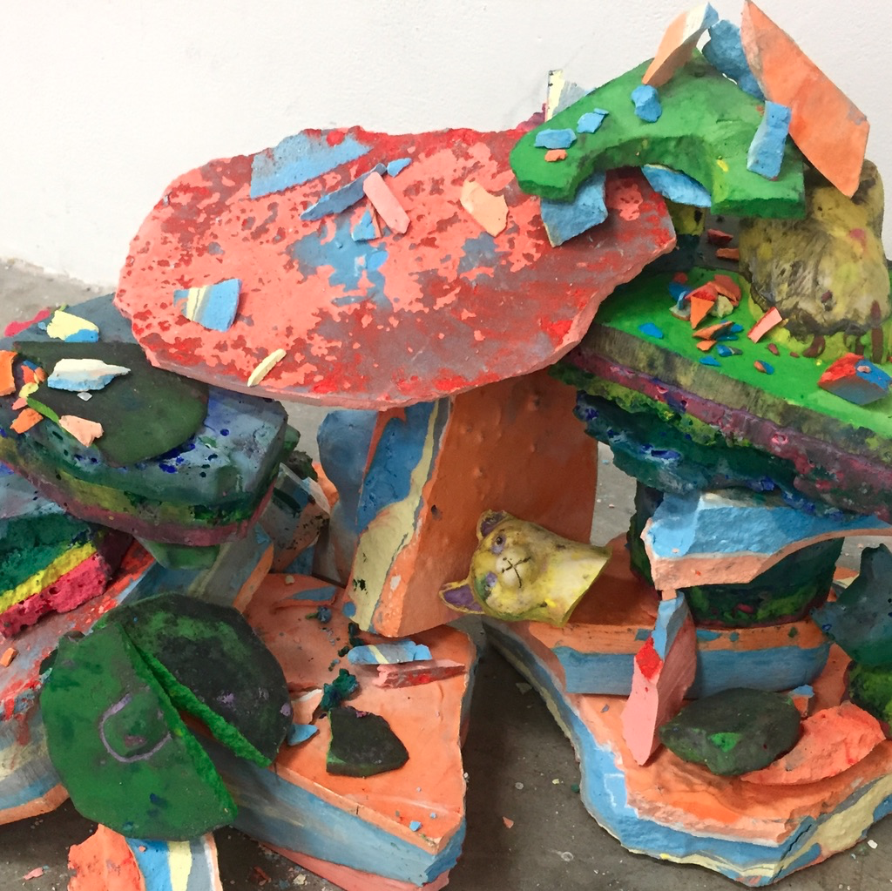

I found that the rocks lent themselves to performance more than installation. The manual stacking and restacking of the rocks felt akin to the arbitrary, whimlike modality I ascribed to the proposed actor behind creationist Earth, and helped illustrate the concept that the Earth’s crust was dynamic rather than static – existing in an ongoing state of change as we come into contact with it with our human bodies.

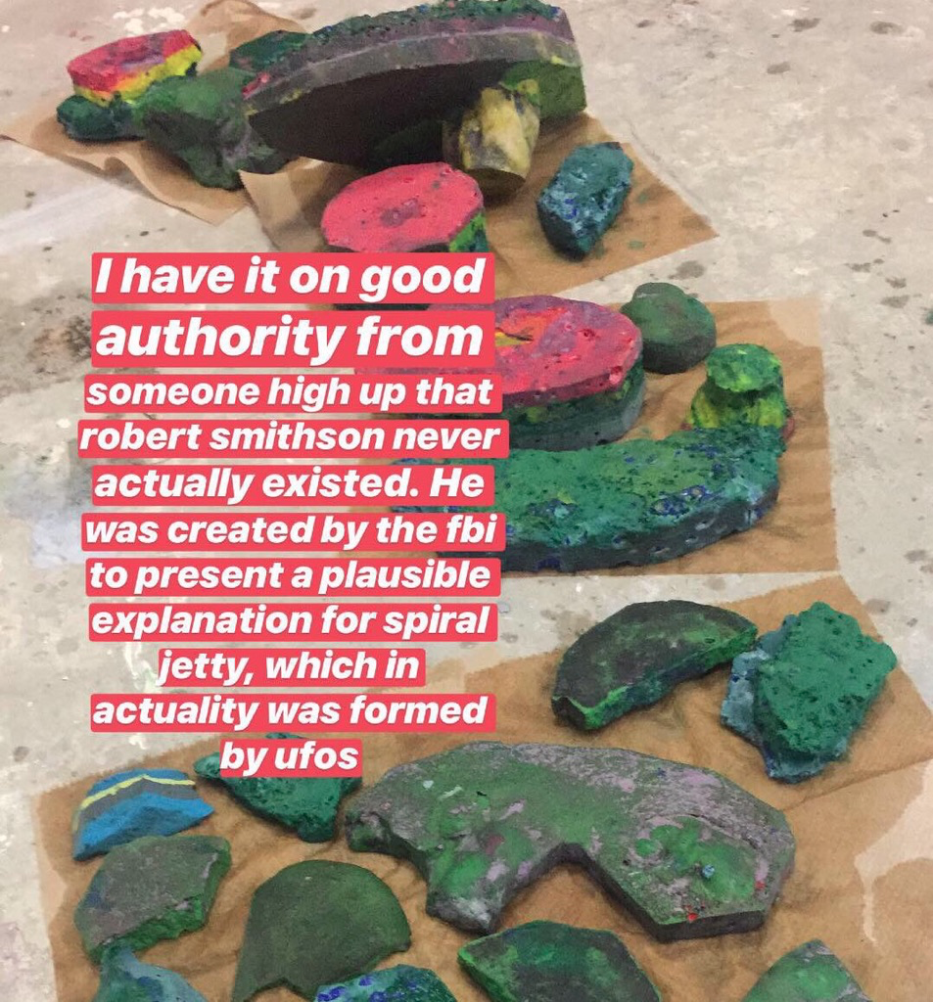

*I had a dream that I got into an argument with a guy who tried*

*to tell me that my artificial rocks were an example of “Land Art.”*

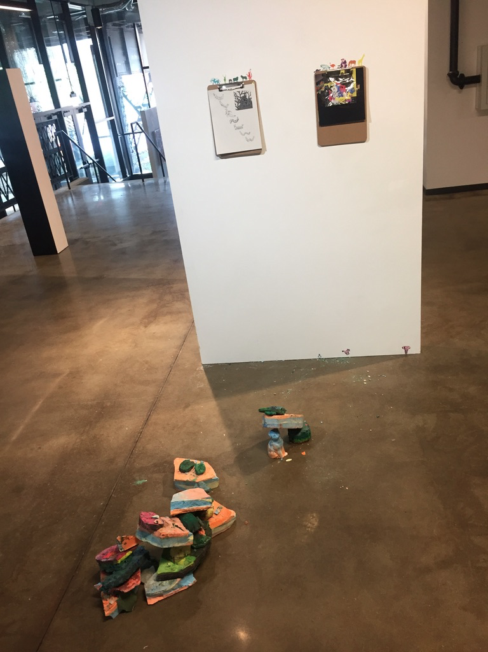

At the Painting and Printmaking senior show I used my collection of rocks, expanded after a second set of pours, in a performance where I gradually restacked the pile, allowing the configuration to migrate across the room in what I termed continental drift.

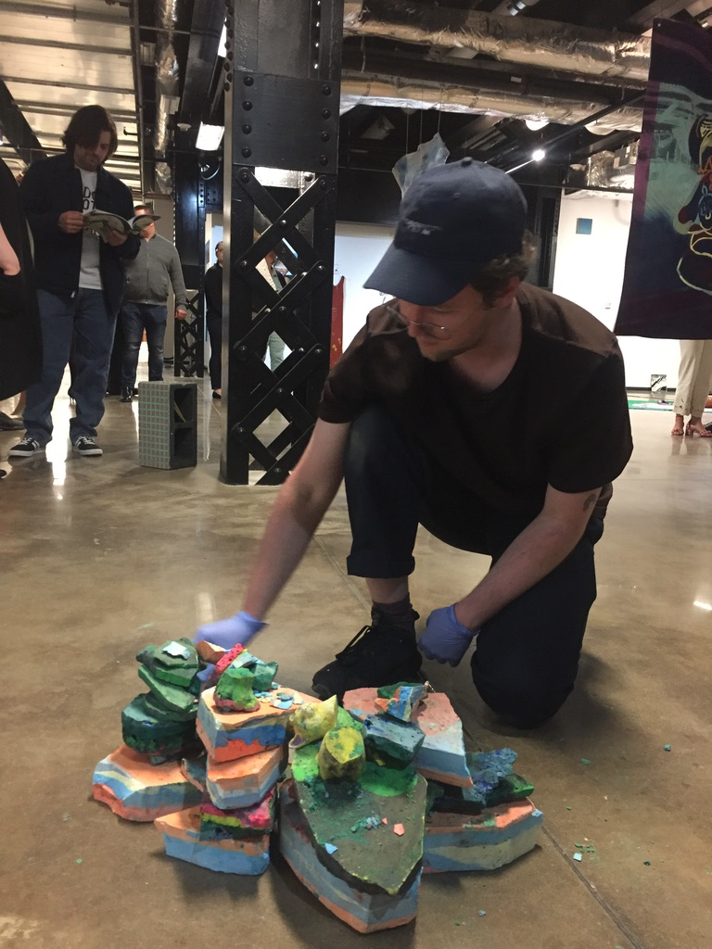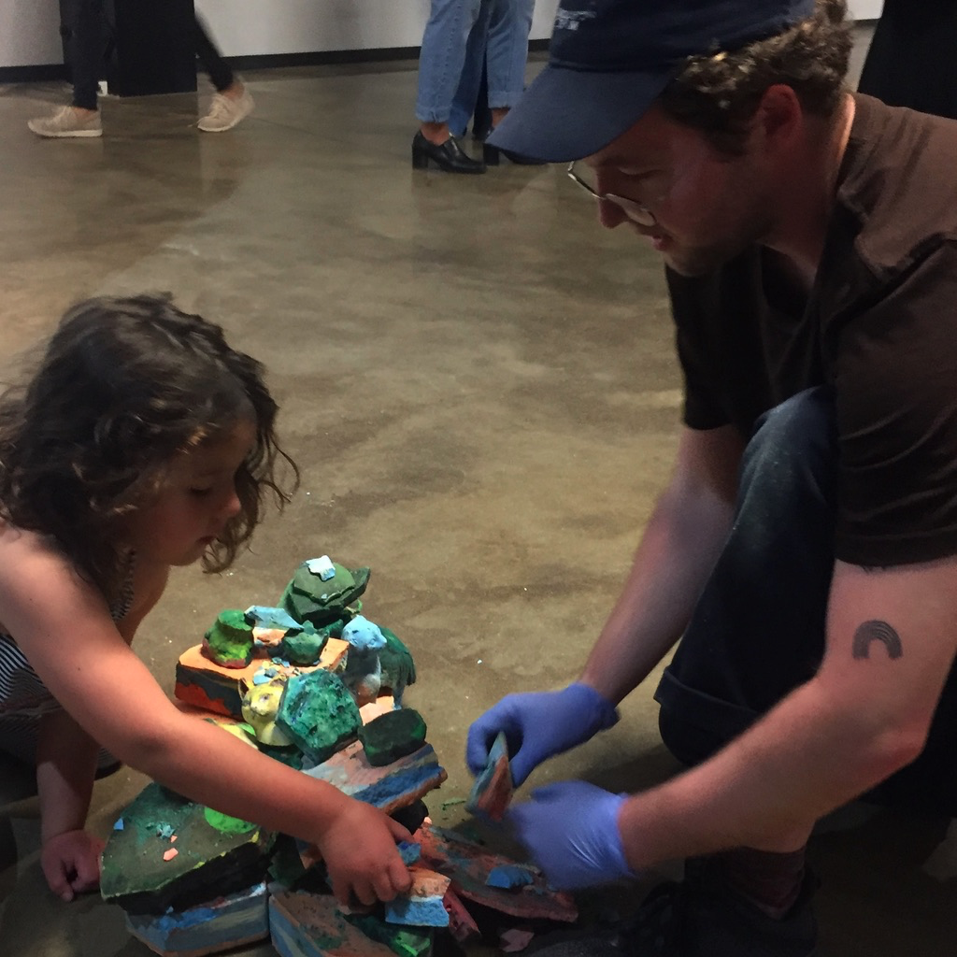

I was thrilled when my vision of using the rocks as a tool for pedagogy became a reality. Pictured above is one of the two little kids (one being the daughter of a professor of mine, the other a complete stanger) who joined me in geological play.

*The following are the illustrations I created for my publication about the mineral self and mineral earth.*

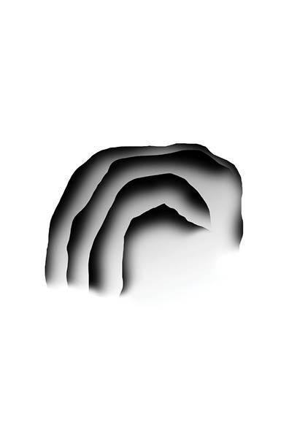

*Cave Entrance*

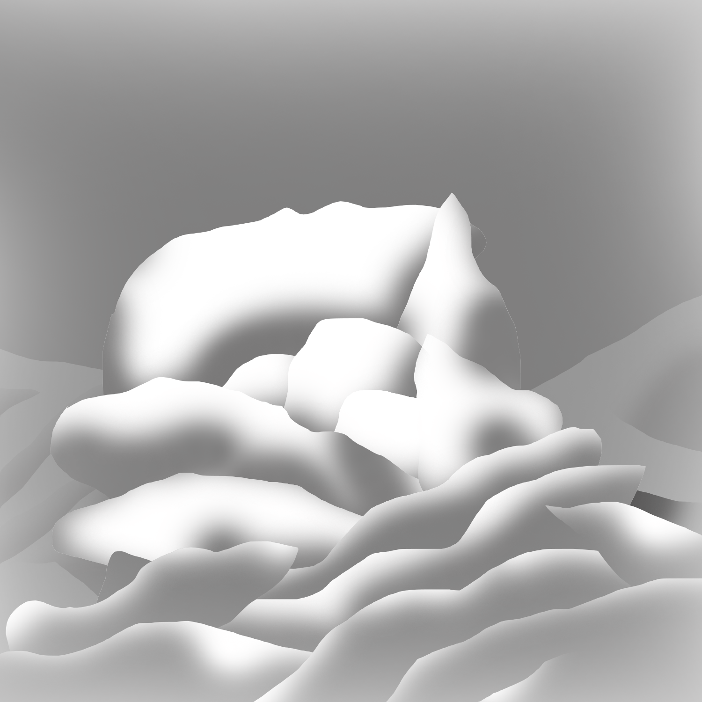

*Karst 1*

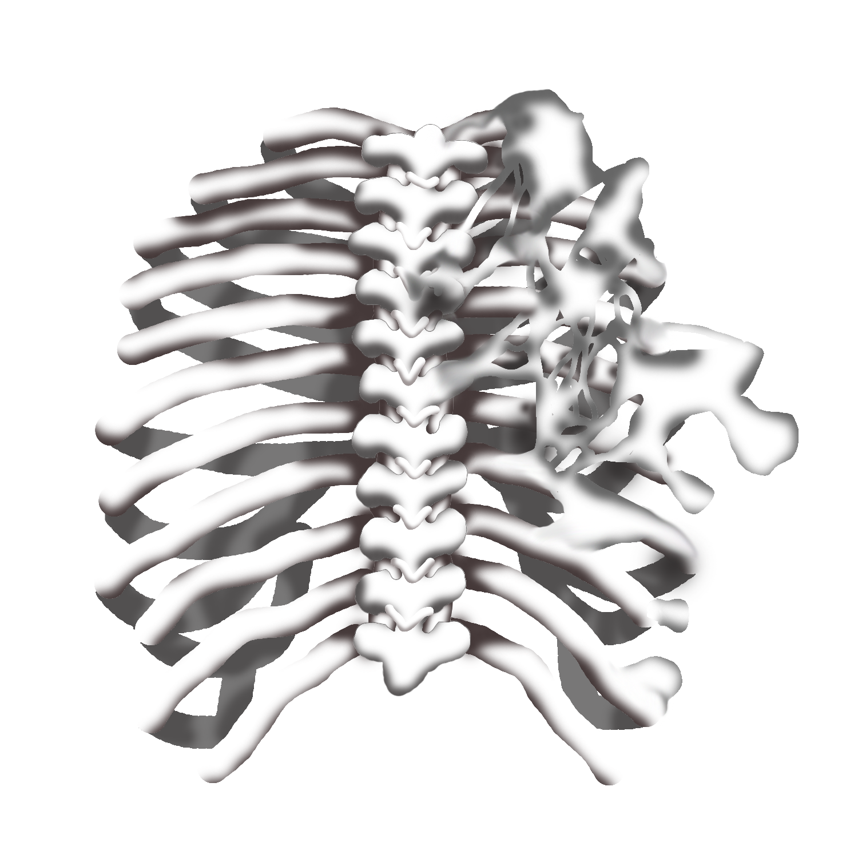

*Deposition - Fibrodysplasia Ossificans Progressiva*

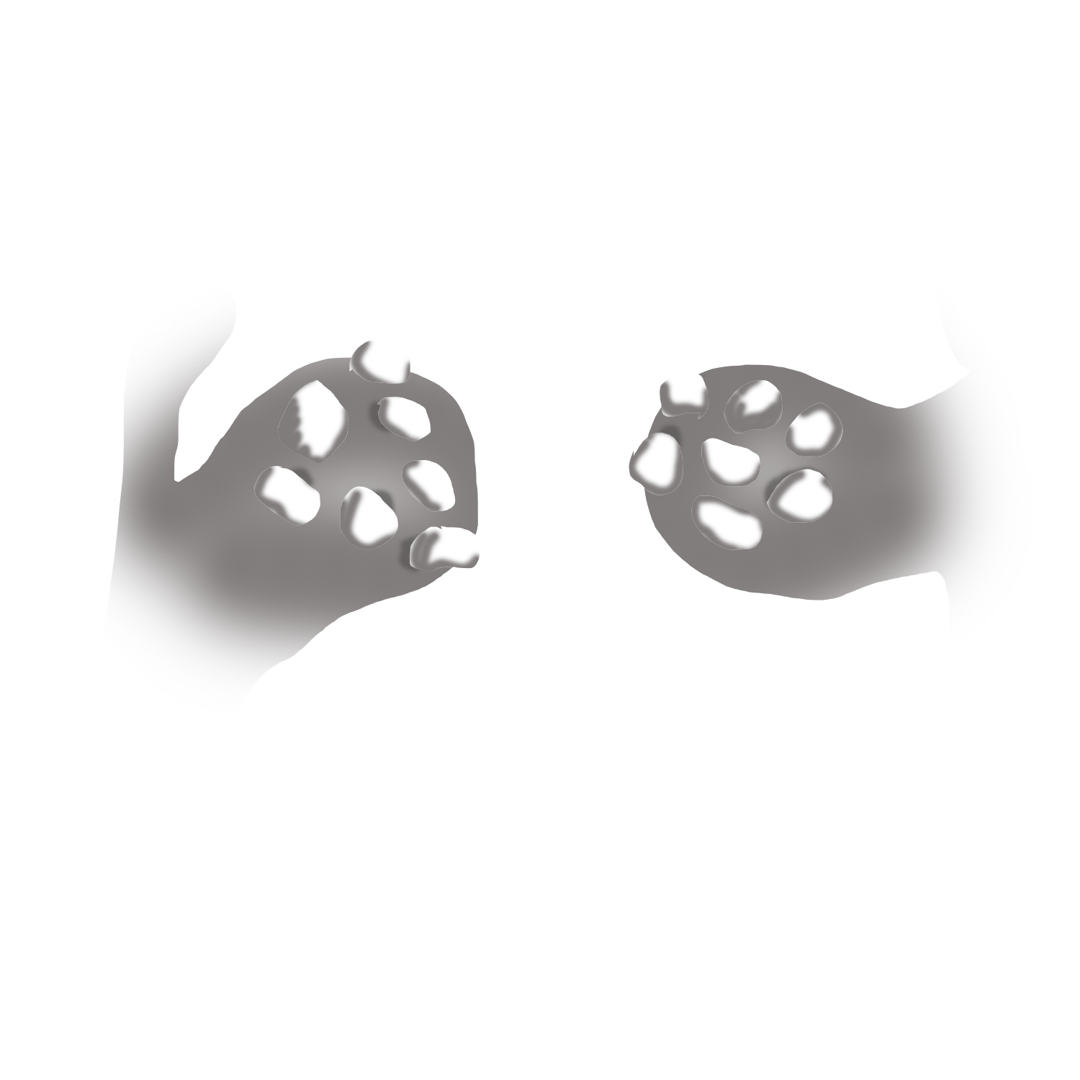

*Sedimentation - Tonsilloliths*

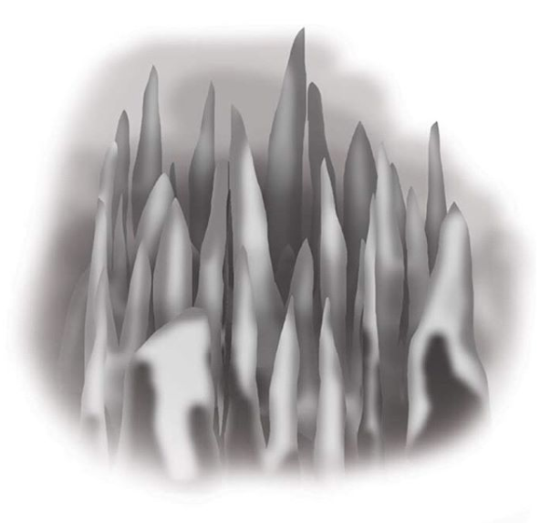

*Karst 2*